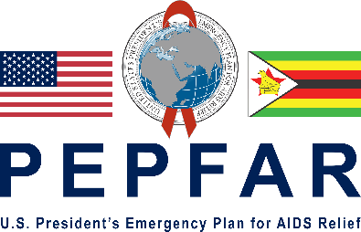
2021 PEPFAR Heroes Nomination Form
The United States President’s Emergency Plan for AIDS Relief (PEPFAR), in partnership with the Zimbabwe Network of People Living with HIV (ZNNP+) call on you to nominate your fellow Zimbabweans to receive the 2021 PEPFAR Heroes Award for outstanding and meaningful contribution towards the HIV and AIDS response in Zimbabwe for the past 18 years. A PEPFAR Hero has made a significant contribution to the improvement of the HIV response in unique and creative ways that:
- Have gone above and beyond the call of duty to create an enabling environment for people living with HIV to easily access health related services;
- Have influenced HIV and AIDS policies and programming to create platforms, opportunities and solutions for the benefit of adolescent girls and boys, young women and men, faith-based communities, key populations and people with disability in an equitable manner.

If you know an individual in your community whose outstanding actions and achievements are worth celebrating, nominate him or her for the 2021 PEPFAR Heroes Award. Call the ZNNP+ Kutabila WhatsApp number (0734349479) or, complete the online nomination form on: https://ee.humanitarianresponse.info/preview/5v4xk1S9 . Alternatively, complete and submit a nomination form to; info@znnp.org copying NyakwendeG@state.gov by June 30, 2021. Nomination guidelines are available on: https://zw.usembassy.gov and www.znnp.org .

Nominator Information

Last Name:…………………………………………. ………. First name: …………………………………………………………………………………………..

Contact Details:………………………………………………………………………………………………………………………………………………………………………………………….

…………………………………………………………………………………………………………………………………………………………………………………………………………………..

Date of Birth:……………………….. Cellphone Number: ………………………………………………………………………………..

Nominee (Hero) Information:

Last Name:……………………………………………………… First Name:………………………………………………………………………………………………

Contact details: …………………………………………………………………………………………………………………………………………………………………………………………

…………………………………………………………………………………………………………………………………………………………………………………………………………………..

Date of Birth:…………………………………… Cellphone number:………………………………………………………………………………….

Registration Number:………………………………….

Intervention/Type of work

- What is the name, objective of program(s) or project(s) and geographical coverage for which the nominee deserves recognition?

……………………………………………………………………………………………………

……………………………………………………………………………………………………

- Describe the work focusing on the overarching measurable/tangible contribution and accomplishments for which the nominee is being nominated for recognition.

……………………………………………………………………………………………………

……………………………………………………………………………………………………

……………………………………………………………………………………………………

- Is your nominee willing to provide evidence of the achievements as well as answer questions that may be asked by the adjudicating committee?

Yes/No

- Give names of three different opinion leaders or prominent persons in your community who can endorse your nomination?
……………………………………………………………………………………………………
……………………………………………………………………………………………………
……………………………………………………………………………………………………

- Is your nominee willing to be photographed and featured in a documentary and PEPFAR Calendar for 2022 and any other public platforms?

Yes/No

- Has your nominee received any special Awards and Recognitions before? If so, please explain below:

………………………………………………………………………………………………………

………………………………………………………………………………………………………

……………………………………… …………………………………………..
Signed by Nominator Signed by Nominee

Date:…………………………….. Date:…………………………………….

